MODULE-02

INDIVIDUAL TASK-02

Machine Learning Powered Chatbots

Abstract
Machine Learning (ML) powered chatbots have transformed human-computer interaction, enabling businesses to provide real-time, intelligent, and personalized assistance to users. Unlike traditional chatbots that rely on fixed rules, ML chatbots use data-driven algorithms and Natural Language Processing (NLP) to understand user intent, predict responses, and continuously improve over time.
This paper explores the architecture, components, applications, advantages, challenges, and future prospects of ML-powered chatbots. It also highlights how machine learning models such as deep learning and reinforcement learning enable chatbots to become increasingly human-like in conversations.
The study emphasizes the growing relevance of these intelligent agents in customer service, healthcare, education, finance, and e-commerce, while discussing the technological and ethical considerations in their implementation.

1. Introduction
In the digital era, businesses and organizations are increasingly relying on chatbots to improve efficiency and customer engagement. A chatbot is a software program designed to simulate human conversation through text or voice. Traditional chatbots, based on rule-based systems, often failed to handle unexpected queries or complex conversations.
The advent of Machine Learning (ML) has revolutionized chatbots by enabling them to learn from data, adapt to user behavior, and provide personalized responses.
ML-powered chatbots combine Natural Language Processing (NLP), Deep Learning, and Reinforcement Learning to understand context, predict user intent, and refine their answers over time. This has made them essential tools in industries like customer service, healthcare, e-commerce, finance, and education.

2. Basics of Machine Learning in Chatbots
Machine Learning is a subset of Artificial Intelligence that allows systems to learn from data rather than relying solely on explicit instructions. ML in chatbots helps in:
- Understanding user queries.
- Predicting the most appropriate response.
- Improving performance from past interactions.

Types of Machine Learning in Chatbots
- Supervised Learning
Chatbots are trained on labeled datasets, such as questions with predefined answers. Example: “What are your working hours?” → “We are open from 9 AM to 6 PM.”
- Unsupervised Learning
Chatbots identify patterns in unlabeled data, such as clustering similar queries to detect common user intents without predefined labels.
- Reinforcement Learning
Chatbots learn through trial and error, receiving feedback on correct or incorrect responses. Over time, the system optimizes for better interactions.
3. Components of ML-Powered Chatbots
- Natural Language Processing (NLP)
NLP allows chatbots to interpret and understand human language. Its key tasks include:
  - Tokenization – Splitting text into words or phrases.
  - Named Entity Recognition (NER) – Identifying entities like dates, names, and locations.
  - Sentiment Analysis – Determining the emotional tone of a message.
- Dialogue Management
This component manages the flow of conversation based on context, previous queries, and user intent.
- Machine Learning Models
These models predict appropriate responses. Common approaches include:
  - Decision Trees
  - Support Vector Machines (SVM)
  - Deep Learning Models such as LSTM and Transformer-based architectures
- Knowledge Base
A database storing information for chatbot reference. ML enables bots to expand this knowledge from user interactions.
How to Create a Chatbot using Machine Learning
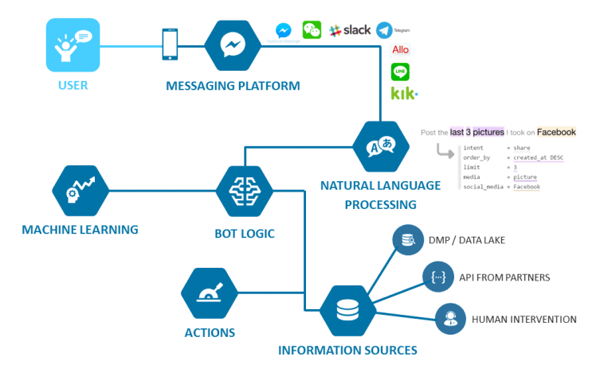
4. Advantages of ML Chatbots
- 24/7 Availability – Chatbots provide continuous service without breaks.
- Personalized Interactions – ML allows remembering user preferences and tailoring responses.
- Scalability – Capable of handling thousands of queries simultaneously.
- Cost Efficiency – Reduces the need for large customer service teams.
- Continuous Improvement – Machine learning enables ongoing learning from user interactions.

5. Applications of ML Chatbots

5.1 Customer Service
Companies like Amazon and Alibaba use chatbots to provide instant support, answer FAQs, and resolve complaints.

5.2 Healthcare
Chatbots like Babylon Health help in symptom checking, scheduling appointments, and virtual consultations.

5.3 E-commerce
ML chatbots recommend products, track orders, and assist with personalized shopping experiences.

5.4 Finance
Chatbots like Bank of America’s Erica assist users with account management, transactions, and financial advice.

5.5 Education
Chatbots support students by answering questions, providing learning resources, and offering tutoring assistance.
6.Learning from Data:
- Training on Large Datasets: ChatGPT, like other ML models, was trained on massive amounts of text data—books, websites, articles, and more. This helps the model learn language patterns, grammar, facts, and even some degree of reasoning.
- Supervised and Unsupervised Learning: ChatGPT uses a mix of these techniques. Supervised learning involves teaching the model with labeled data (e.g., pairs of input-output examples), while unsupervised learning lets the model learn from raw data without explicit labels, often identifying patterns or structure by itself.
8. Natural Language Processing (NLP):
- This is the subfield of AI concerned with the interaction between computers and human language. ChatGPT processes text using NLP techniques, allowing it to understand and generate language that feels natural.
- Transformers Architecture: ChatGPT is based on the transformer architecture, which excels at processing sequential data like text. Transformers use attention mechanisms to decide which words or phrases are important when generating a response.

9. Challenges in ML Chatbots
Despite their advantages, ML-powered chatbots face challenges:
- Complex Queries – Ambiguous language or slang can confuse bots.
- Knowledge Gaps – Limited or outdated data can reduce accuracy.
- Data Privacy – Sensitive user information requires secure handling.
- High Initial Costs – Developing advanced ML chatbots requires significant investment.
- Maintenance Needs – Continuous updates are necessary to improve performance.

10. Technologies Behind ML Chatbots
- Natural Language Understanding (NLU) – Interprets user inputs.
- Machine Learning Algorithms – Enable predictive response generation.
- Deep Learning Frameworks – Tools like TensorFlow, PyTorch, and Hugging Face Transformers are widely used.
- Cloud Platforms – Google Dialogflow, Microsoft Bot Framework, and IBM Watson offer ML-based chatbot services.

11. Future of ML Chatbots
- Advanced Conversational AI – Large models like GPT and BERT improve conversational capabilities.
- Emotion Recognition – Chatbots may detect and respond empathetically to human emotions.
- Integration with IoT – Chatbots could manage smart devices at home or in workplaces.
- Multilingual Support – Future bots will communicate seamlessly across multiple languages.
- Autonomous Learning – Bots may self-update their knowledge bases without human intervention.

12. Case Studies
- Amazon Alexa – Uses deep learning to understand voice commands and control smart devices.
- Bank of America Erica – Assists millions of customers with banking queries, learning continuously from interactions.
- Babylon Health – Provides AI-driven healthcare consultations, demonstrating real-world ML applications.

10. Rule-Based vs ML-Powered Chatbots
Feature | Rule-Based Chatbots | ML-Powered Chatbots
Learning Ability | None | Learns from data
Handling Complexity | Limited | Can manage complex queries
Personalization | Minimal | High
Scalability | Moderate | High
Continuous Improvement | No | Yes

11. Conclusion
Machine Learning has revolutionized chatbots, turning them from simple scripted assistants into intelligent conversational agents capable of understanding, learning, and interacting with humans. By leveraging NLP, deep learning, and reinforcement learning, ML chatbots offer personalized, efficient, and scalable communication solutions across industries.
While challenges such as data privacy and complex queries remain, the future of ML-powered chatbots is promising, with advancements in conversational AI, emotion recognition, multilingual capabilities, and autonomous learning poised to enhance human-computer interaction further. Organizations adopting ML chatbots gain a strategic advantage, improving customer engagement and operational efficiency.

